Data Cleaning
- Roundoff the column

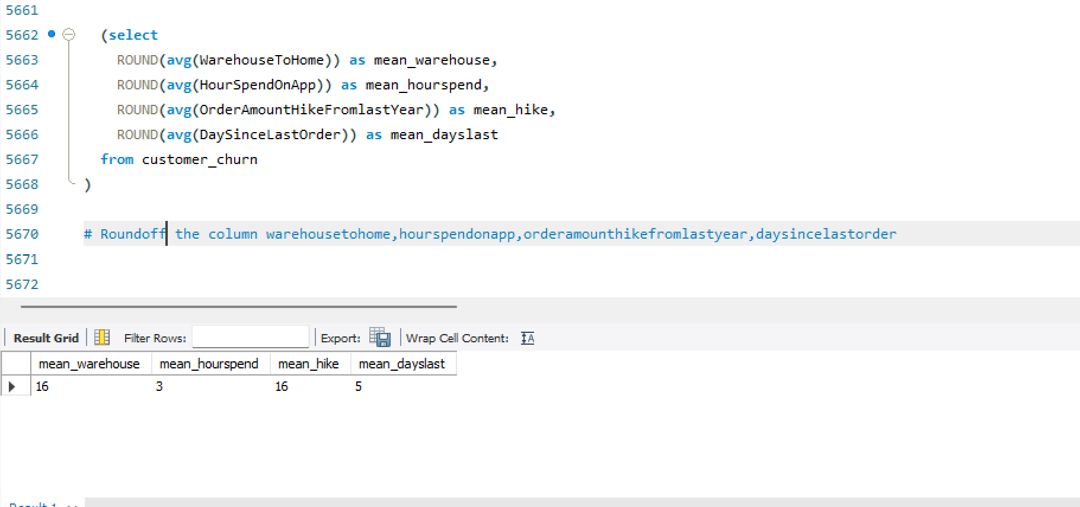

Delete Warehouse value greater than 100
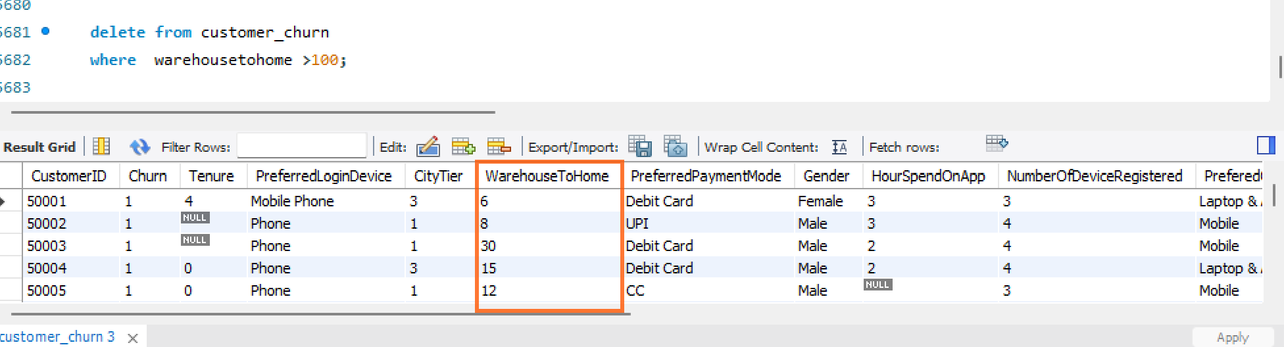

Dealing with Inconsistencies
- Replace occurrences of “Phone” in the 'PreferredLoginDevice' column and “Mobile” in the 'PreferedOrderCat' column with “Mobile Phone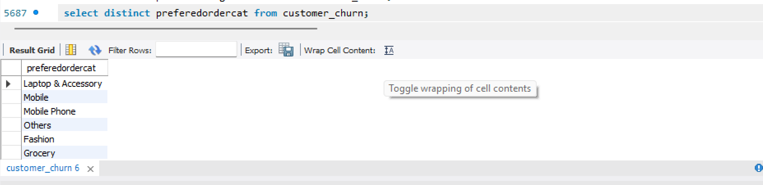

- Standardize payment mode values PreferredPaymentMode column 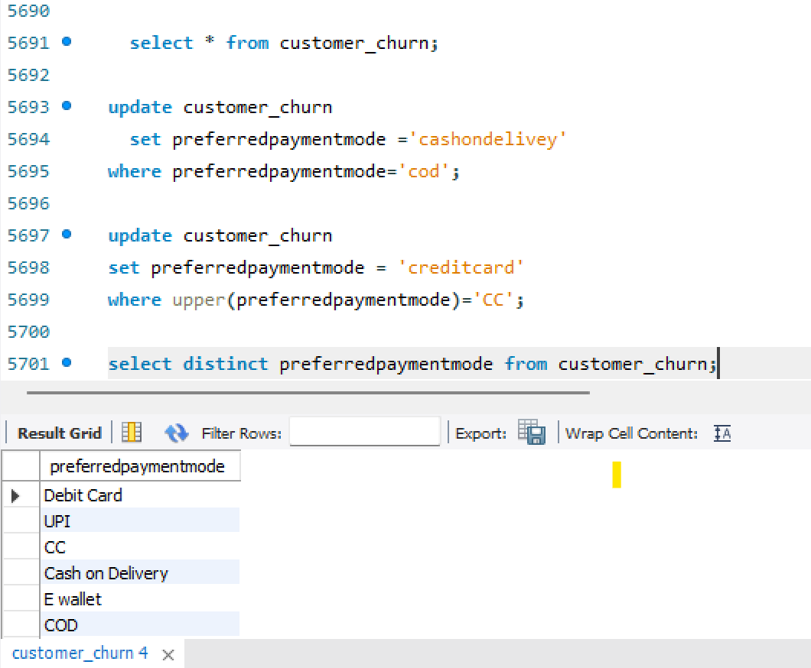

Data Transformation
- Rename both column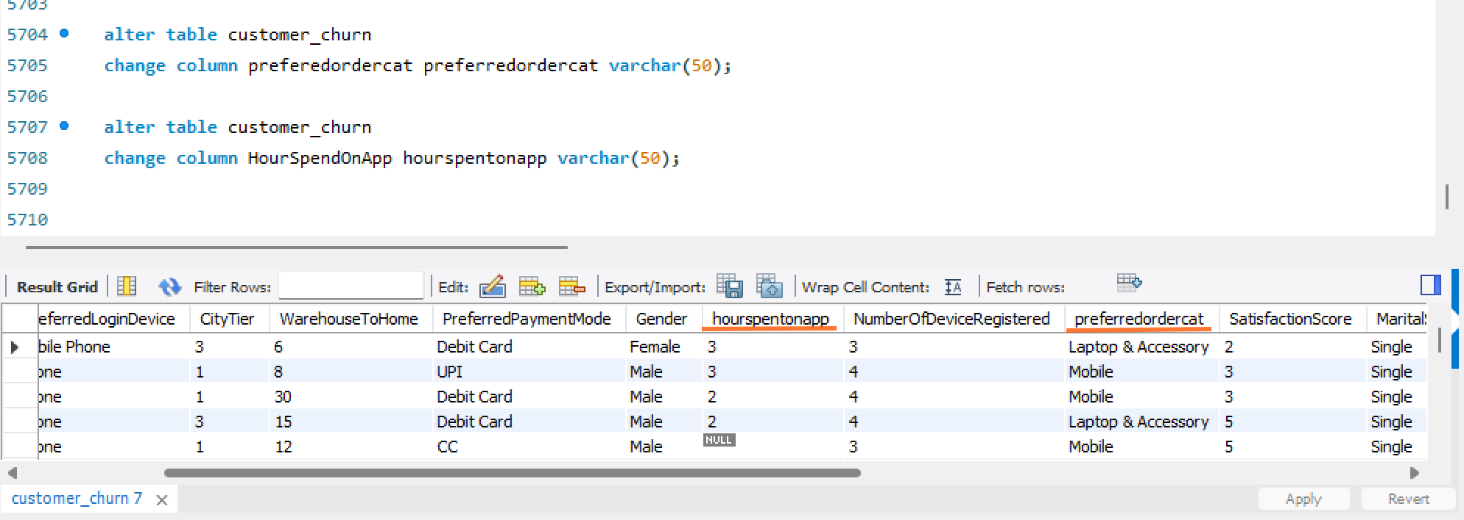

- Add new column complaint received and churn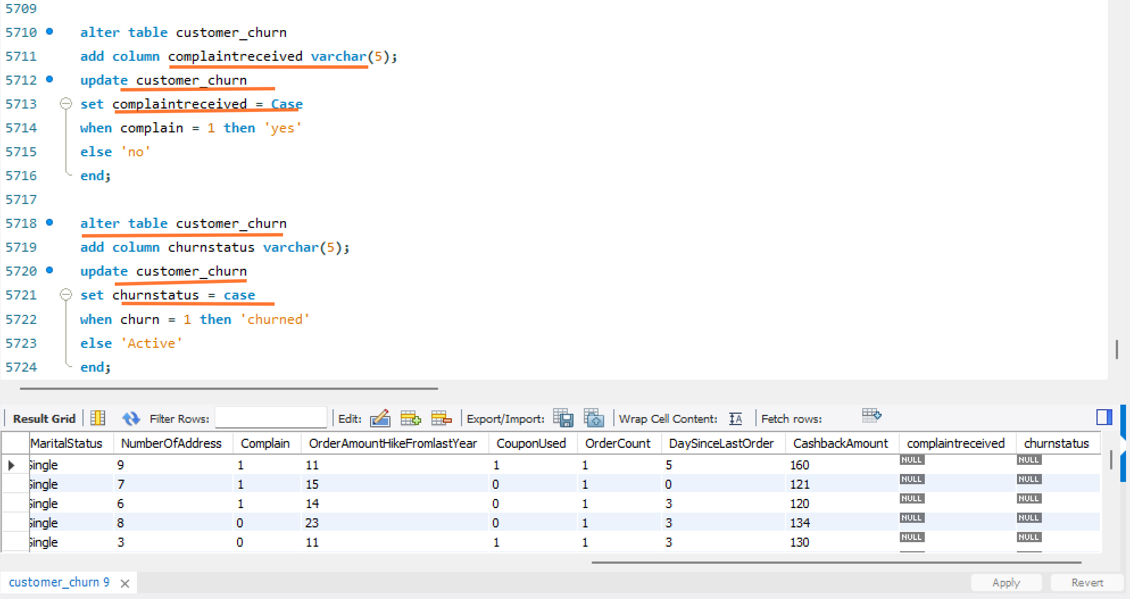

- Drop two column complain and churn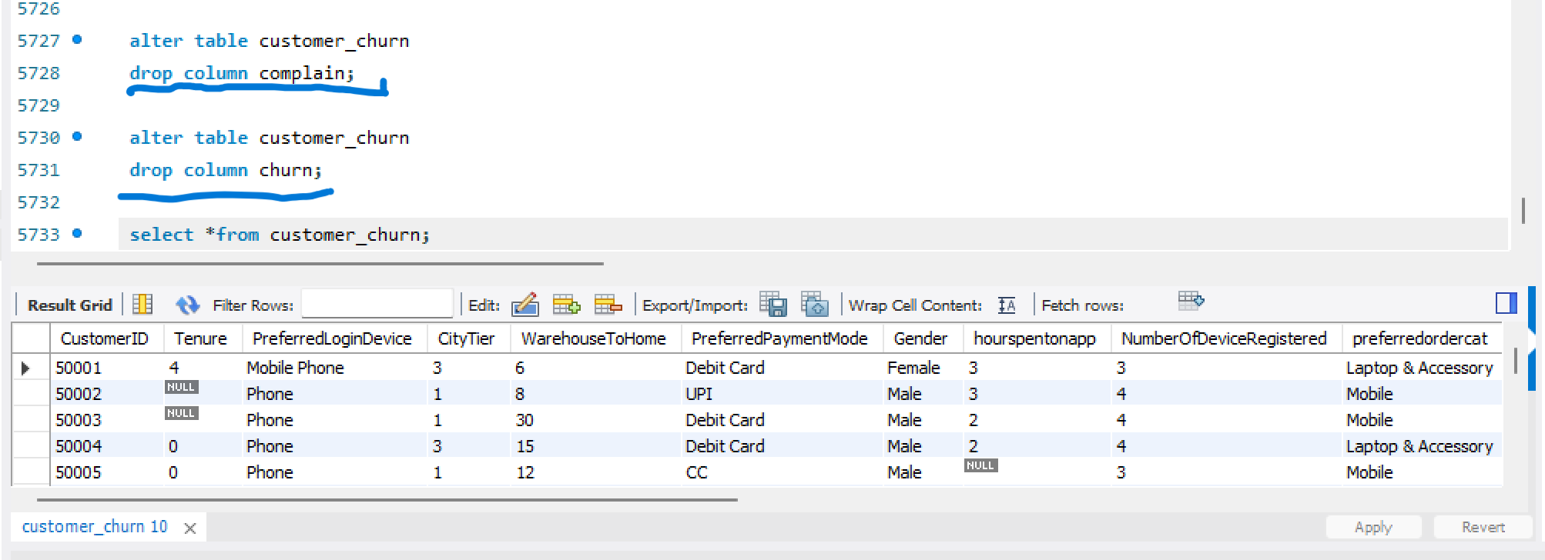

Data Exploration and Analysis
- Active customerscounts from the dataset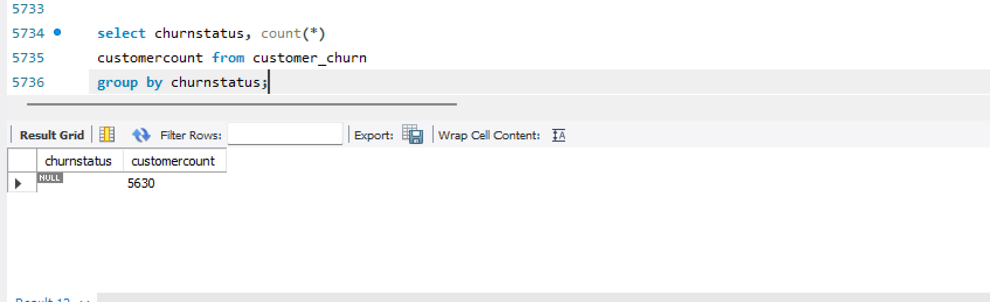
- Display the average tenure and total cashback amount of customers 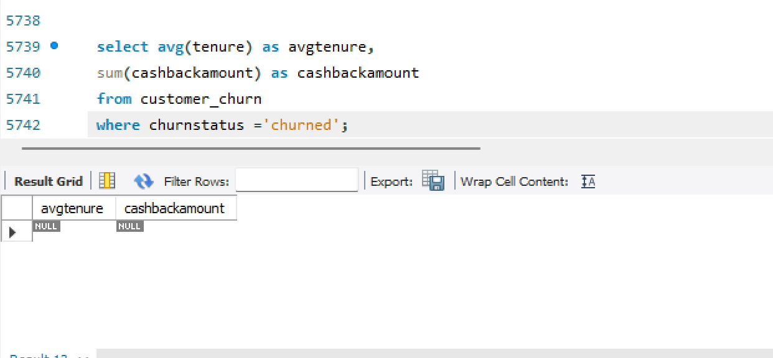

- Identify the city tier with the highest number of churned customers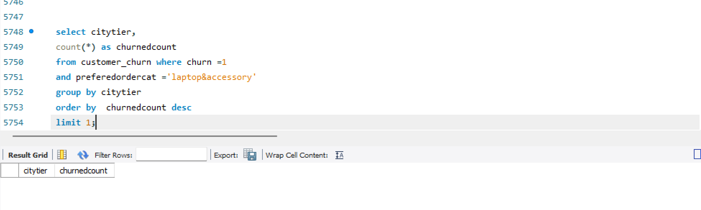

- Identify the most preferred payment mode 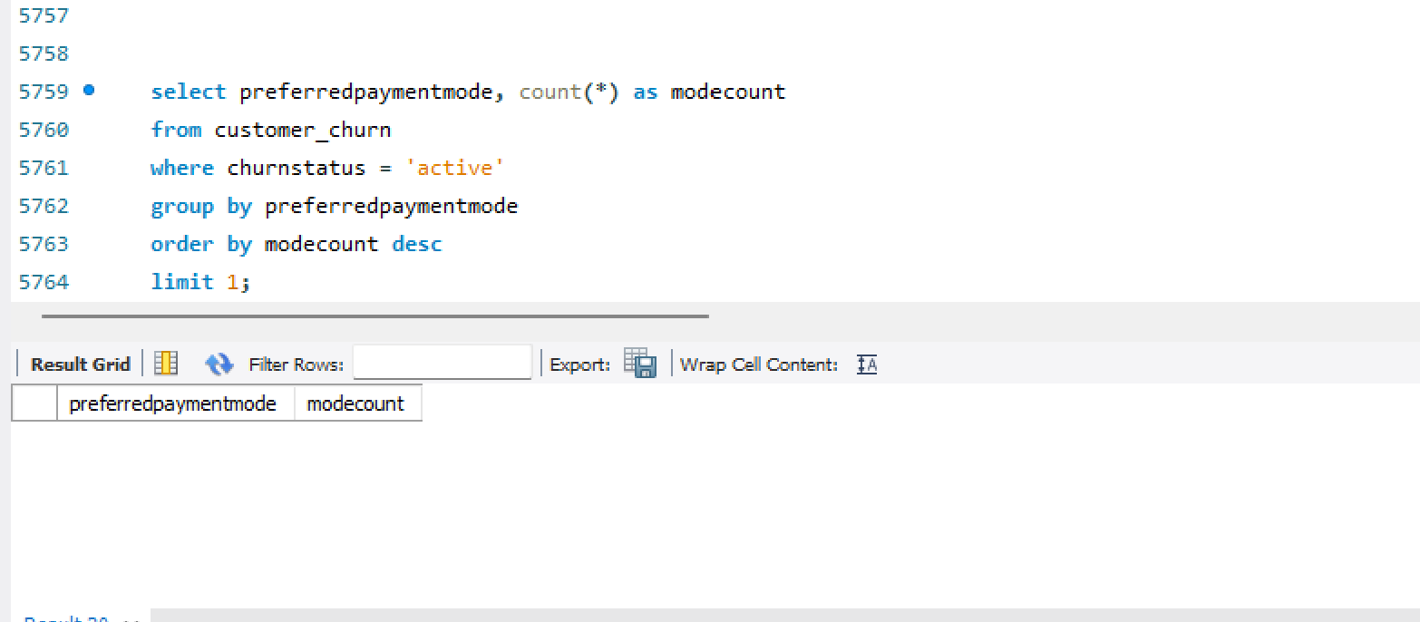

- Calculate the total order amount hike from last year for customers 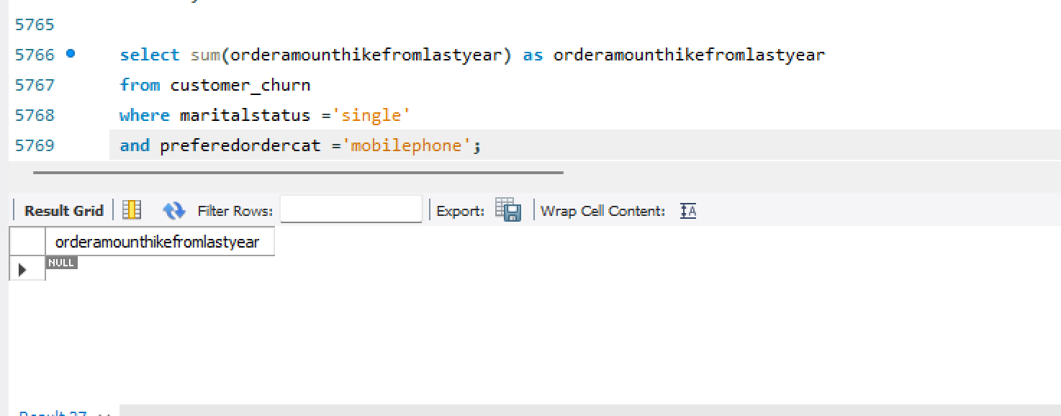

- Average number of devices registered among customers who used UPI 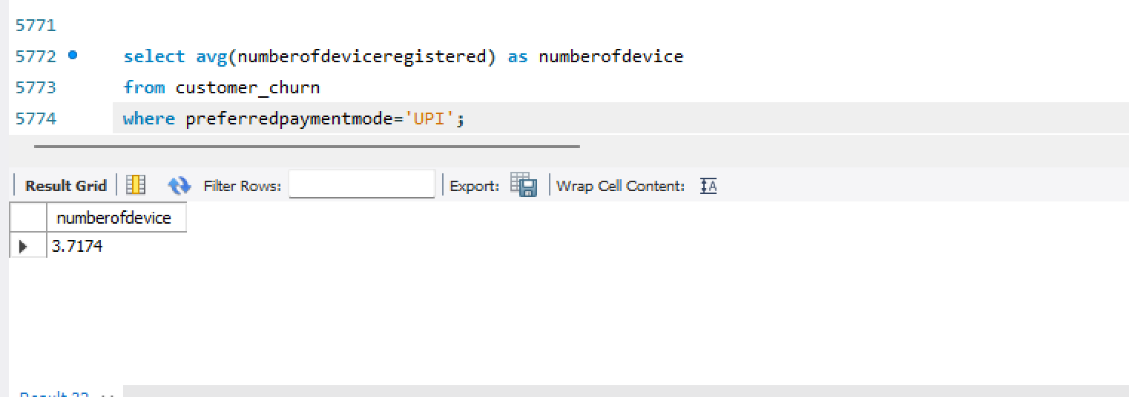

- City tier with the highest number of customers 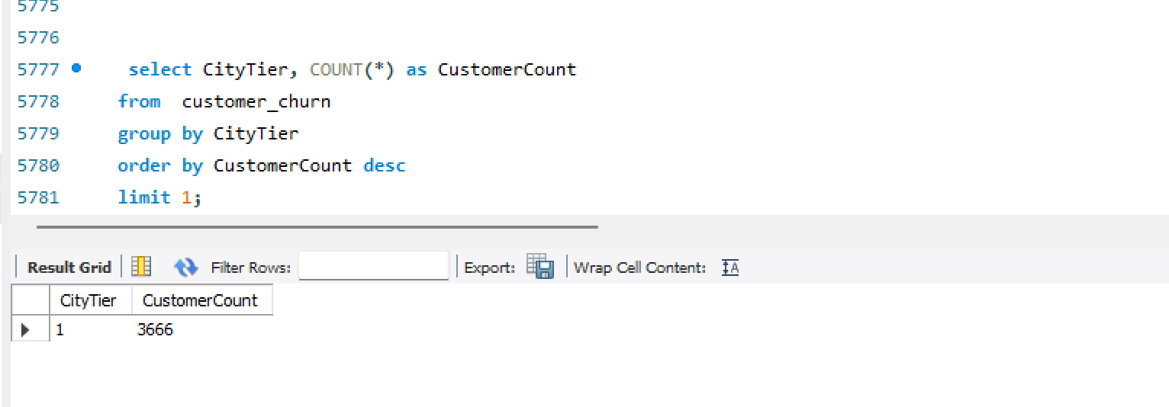

- Identify the gender that utilized the highest 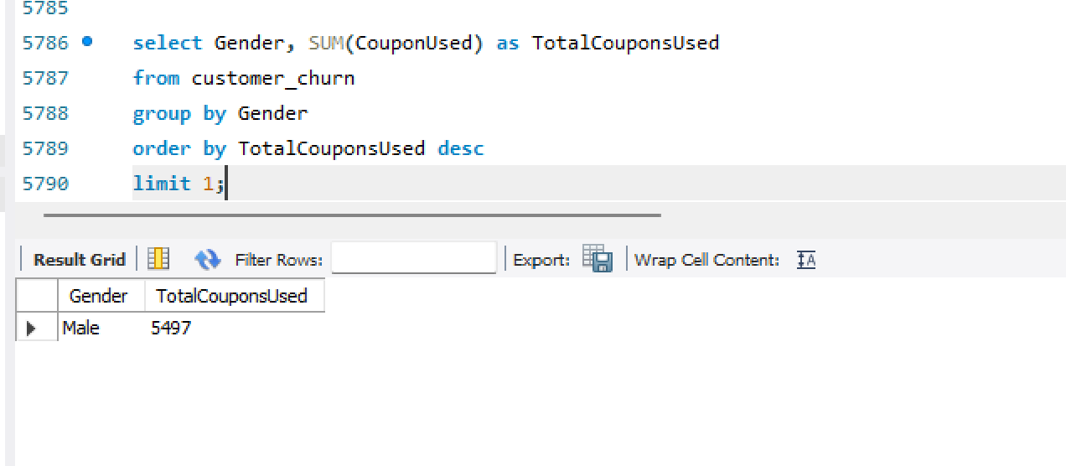

- Calculate the total order count for customers satisfaction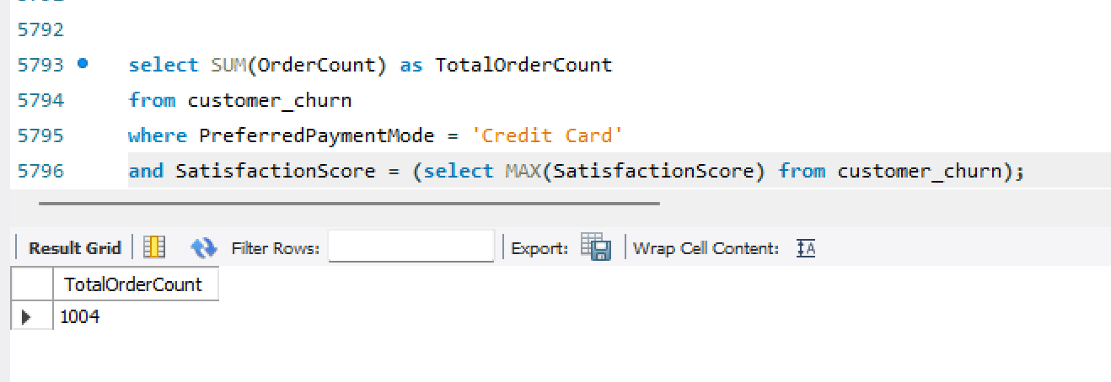

- List the preferred order category among customers

- List the top 3 preferred order categories highest average cash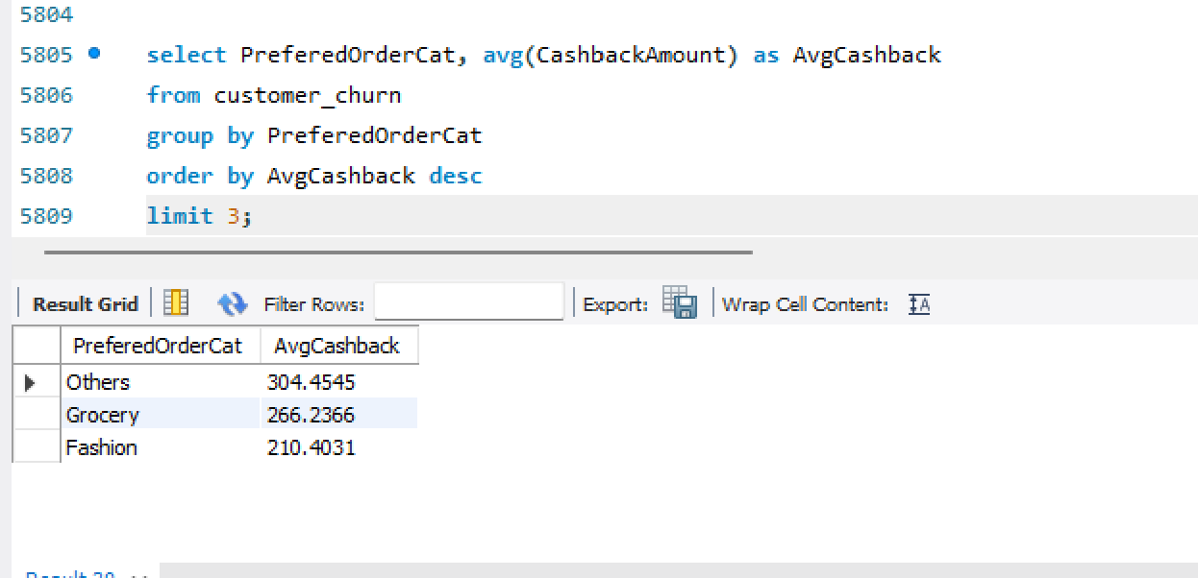

- Preferred payment modes of customers order more than 500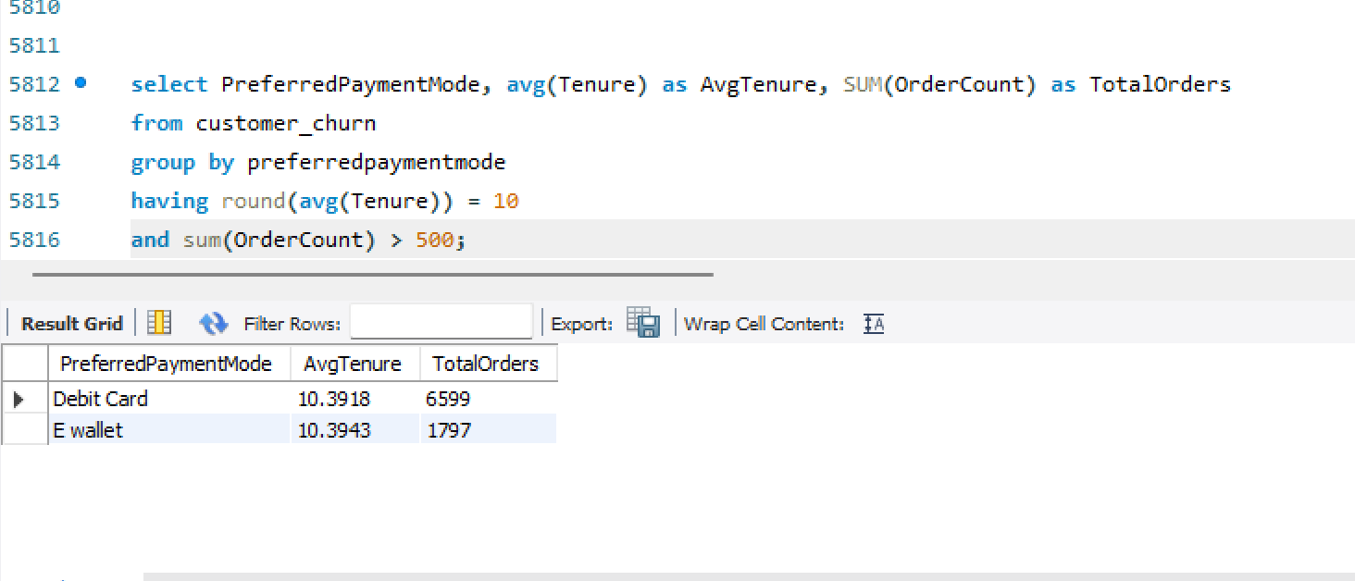

- Customer’s order details who are married, live in City Tier-1, and their order counts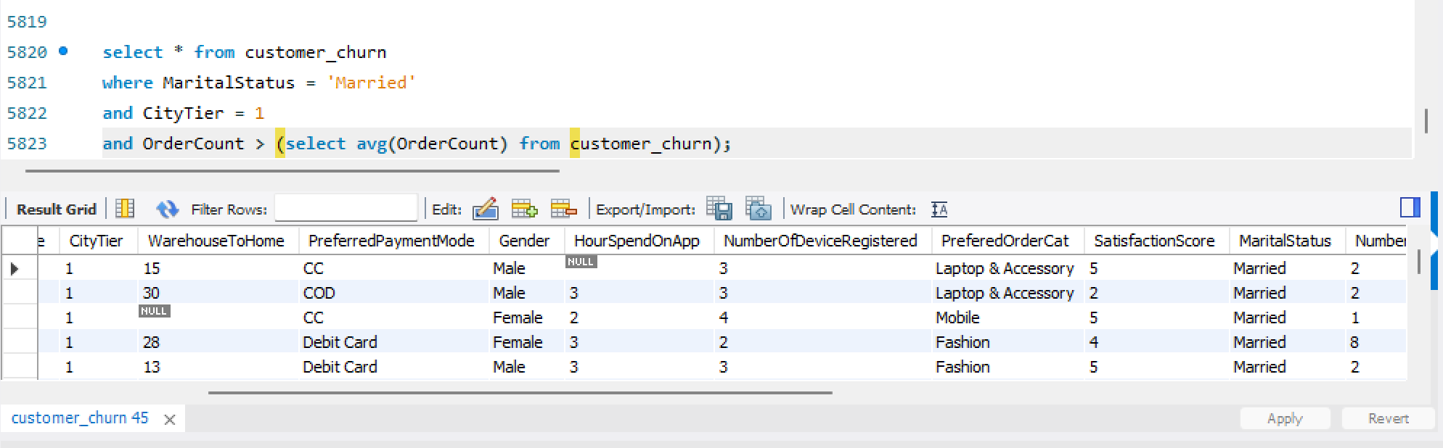

- Create a ‘customer_returns’ table in the ‘ecomm’ database and insert data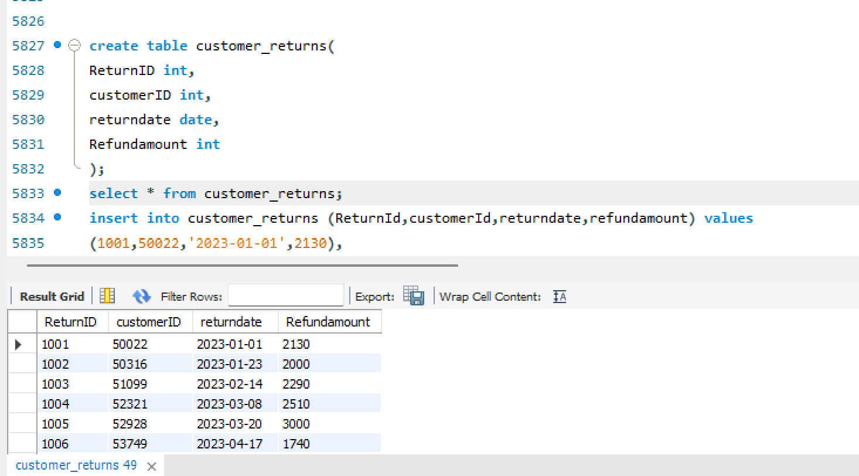

- Display the return details along with the customer